LORDIMAS Experts Group

In January 2025, the Living-in.EU movement launched a Call for Experts to co-create the next phase of LORDIMAS—the Local and Regional Digital Maturity Self-Assessment Tool.
LORDIMAS supports cities and regions in evaluating their digital transformation journey, offering insights, benchmarking, and policy recommendations. To ensure the tool remains relevant, community-driven, and grounded in real-world needs, 12 experts from across Europe have been selected to join this co-creation process.
These professionals bring deep knowledge in areas such as digital governance, interoperability, emerging technologies, and local innovation. Together, they will collaborate with Living-in.EU and its partners to identify good practices, address challenges, and improve the tool based on practical experiences and strategic foresight.
We’re proud to introduce this diverse and dedicated group of experts shaping the future of digital transformation in Europe.

List of Experts

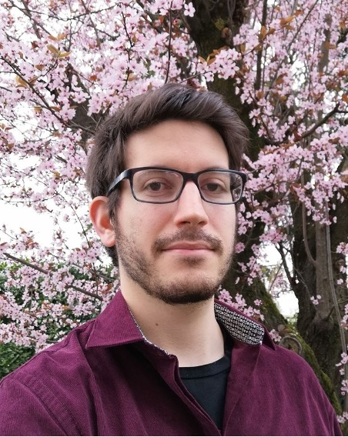 | Andrea Pareschi - Emilia-Romagna Region - Delegation to the EU  Andrea Pareschi (1991) works as a policy officer, primarily focusing on digital transformation and on competitiveness, within Emilia-Romagna Region’s Delegation to the EU. In this capacity, he was notably involved in the development of the European project DT4REGIONS (2021-23), which had Emilia-Romagna Region as its coordinating partner. Working in synergy with digital stakeholders and EU institutions in Brussels, DT4REGIONS aimed at the creation of a European platform for regions and local authorities, gathering digital solutions based on Big Data and AI which could respond to shared policy challenges. Andrea Pareschi also holds a Ph.D. in Political Science, European Politics and International Relations, jointly awarded by the Sant'Anna School of Advanced Studies and the universities of Siena, Florence and Pisa, and he has published academic articles in several international journals. His research revolves around European politics.  LinkedIn  Organisation website: https://www.regione.emilia-romagna.it/sede-di-bruxelles
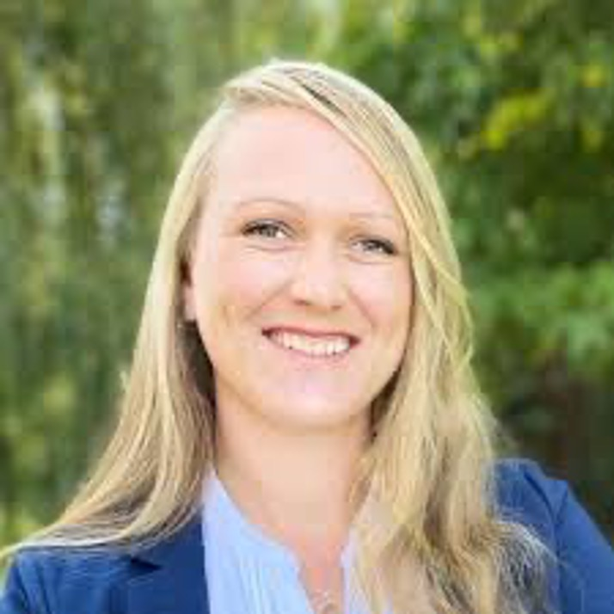 | Aurélie Louguet - SILK Association – Societal Intelligence for & by Local Kommunities  Aurélie Louguet is a specialist in digital services and sustainable development for cities and regions, with 20 years of experience working across Europe. She has helped public authorities improve how they use technology, manage data, and plan for the future. She has led many international projects supporting local governments in making better decisions using digital tools, especially in areas like energy, transport, and city planning. She has worked with the European Commission and other public organisations to design practical solutions that match local needs. Aurélie is also trained in digital systems design and is committed to supporting open data, collaboration, and learning between cities and regions. She speaks fluent English and French, has a good command of Spanish. She is passionate about helping communities make the most of digital opportunities in ways that are inclusive, effective, and sustainable.  LinkedIn  Oranisation Website: https://www.association-silk.eu/
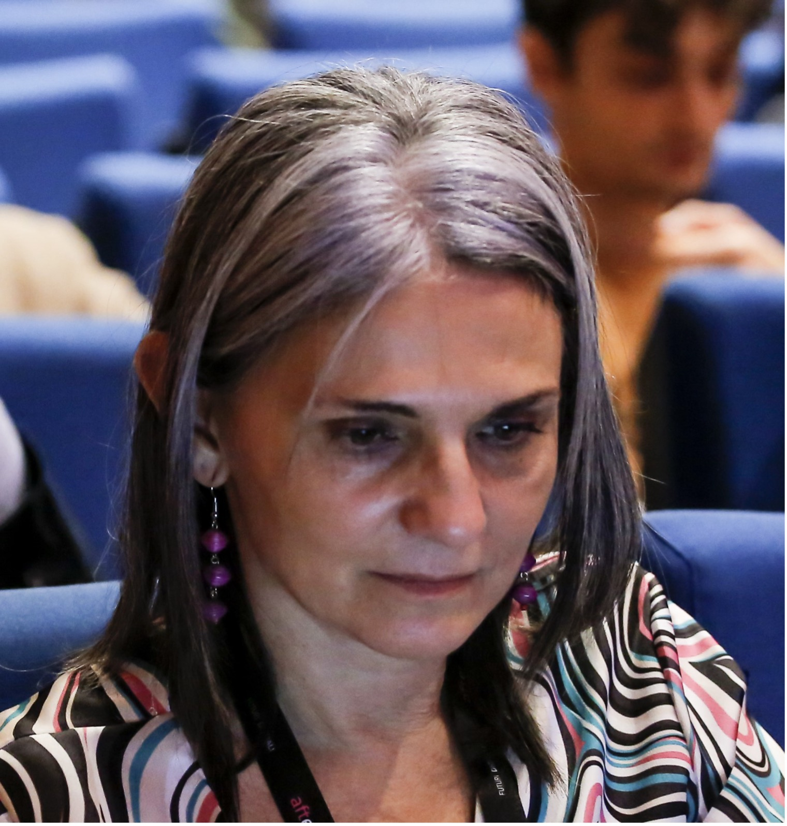 | Barbara Santi - Emilia Romagna Region  Barbara Santi has been working on the Digital Agenda of the Regione Emilia-Romagna since 2010, with particular reference and passion to digital skills, local policies of participatory and inclusive innovation, the gender gap in the technological field and, thanks to statistical training, the measurement of digitization in all its forms.  She is the Project Manager of DESIER, the DESI Index regional version with which we measured the digitalisation of our 330 municipalities since 2022.  LinkedIn  Organisation website: https://www.regione.emilia-romagna.it
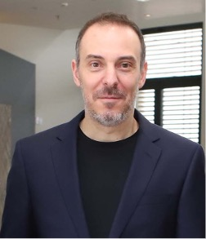 | John Tziouras - Region of Western Macedonia  John Tziouras is a Doctor of Law on Space Law at Aristotle University of Thessaloniki (A.U.Th.), and former scholar of A.U.Th.'s Research Committee. He holds an LL.M. in International and European Legal Studies at A.U.Th., an LL.M. in Law and Technology at Tilburg Law School, and he is enrolled in the 2026 class of the Master’s programme in Open eGovernment at Stockholm University. He was the founder and legal consultant of Spaceanalytica, a consulting platform for startups in the space sector, while he is a member of the AI SpaceLaw Society for the Greek chapter. He is a significant contributor for Ergoncell, an IT consultant based in Greece specialized at NetZeroCities Pilot Cities Progammes, and he worked for local governmental authorities on Green and Digital transition portfolio as special associate for the City of Kozani on the EU Cities Mission. Currently he is a policy associate at the Digital World Summit Greece’s initiative.  LinkedIn  Organisation website: https://en.pdm.gov.gr
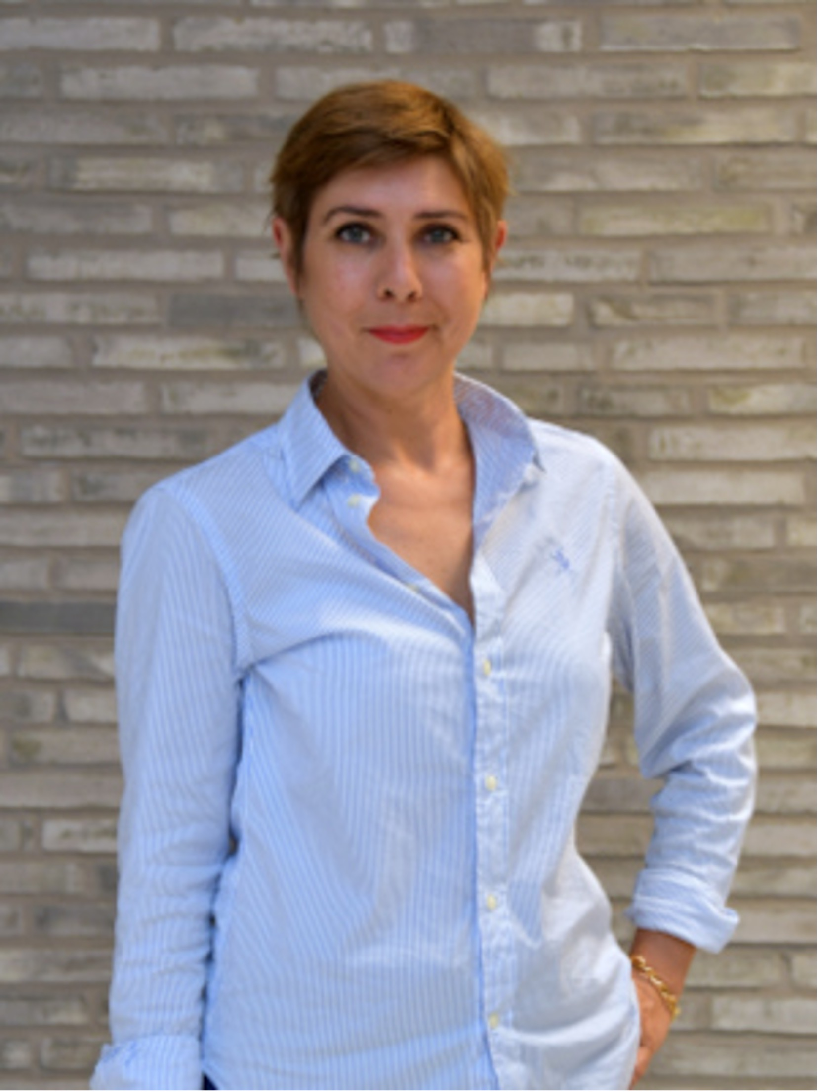 | Laurence Johannsen - Luxembourg Institute of Science and Technology (LIST)  Laurence Johannsen is research engineer at LIST in the AI readiness and Assessment (AIRA) team.  As educational background, she completed master degrees in management sciences and international business.  Her fields of expertise cover user-centric design, organizational creativity, collaborative approaches to support decision-making and impact assessment and outreach.  She manages the Test Before Invest activities of the Luxembourg Digital Innovation Hub (DIH), engaging Luxembourg SMEs in their digitalisation roadmap, through progressive services.  Laurence Johannsen is deeply engaged on the digital transformation of Luxembourg cities through the Smart Communities Network and the Living-in.EU movement, on the one hand. And on the other hand, through the CitCom.ai project which aims at supporting the uptake of AI in cities and communities. In this project, she contributes to the design of a Testing and Experimentation Facility in Luxembourg, enabling cities and Ai innovators to experiment smart city solutions through guided testing and experimentation.  She teaches service & system design at the University and in vocational trainings in Luxembourg and France.  Tamisier, T., Castignani, G., Johannsen, L. (2023). Championing Electromobility with Co-engineered Services Based on Artificial Intelligence and Interdisciplinarity. In: Luo, Y. (eds) Cooperative Design, Visualization, and Engineering. CDVE 2023. Lecture Notes in Computer Science, vol 14166. Springer, Cham. https://doi.org/10.1007/978-3-031-43815-8_24  LinkedIn  Organisation website: https://www.list.lu/
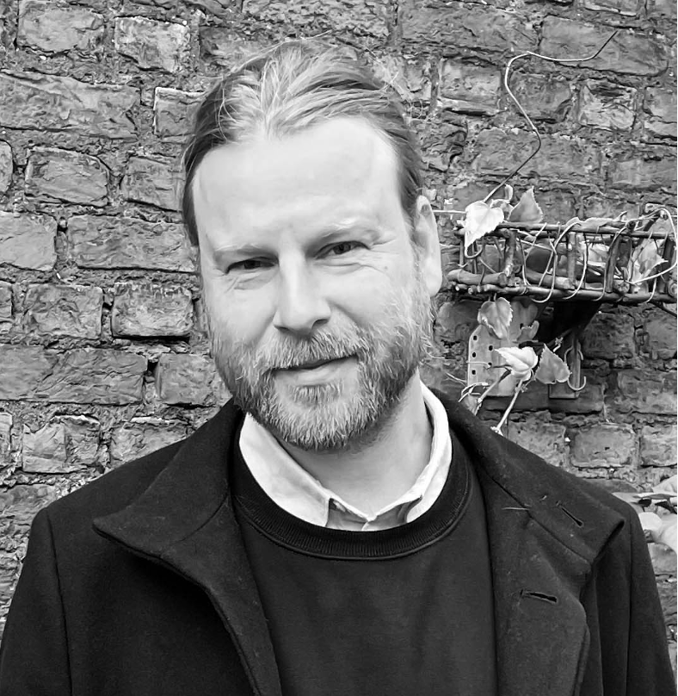 | Maurits Hagemans - PXL University of Applied Sciences & Arts  Maurits is a Lead Researcher in Digitalisation at PXL University of Applied Sciences & Arts, specialising in Digital Twins and emerging digital technologies. He drives innovation and sustainability through collaborative research involving industry and academic stakeholders across multiple projects, including Circular Construction, Digital Information Management, XR applications, and Value Engineering. His expertise encompasses immersive technology, virtual modeling, and digital workflows aimed at enhancing efficiency and circular practices. Additionally, Maurits contributes to the Lectorate Process Innovation & Information Systems at HU University of Applied Sciences Utrecht.  LinkedIn  Organisation website: https://pxl-research.be
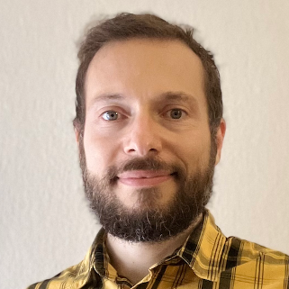 | Raffaele Bini - DIH DATAlife  Raffaele Bini describes himself as a Multi-Potential Engineer, tireless in the path of personal evolution and eager to contribute to the Sustainability of the Planet and a more equitable Society. His passion for creative activities, technical knowledge, personal growth, and spirituality continually pushes him to learn new things and get out of his comfort zone to face daily challenges with enthusiasm, a proactive spirit, and a willingness to listen. In his professional journey, I has had the opportunity to work in different places and areas: thanks to his experiences in continuous improvement and Lean Manufacturing applied to industrial operations, energy efficiency, environmental impacts reduction and digital transformation projects, he has acquired the conviction that digital transition, ecological transition and Lean thinking are the key to sustainability and the future of society. Thanks to these experiences and the colleagues who helped him grow, I has learned that the secret to achieving any result is to invest in the well-being and growth of People and create a Work Environment that generates passion for one's job. He builds meaningful Relationships and Experiences, following his Values of Love, Beauty, Coherence, Integrity, Freedom, Health and Spirituality.  LinkedIn  Organisation website: https://www.dihdatalife.com/en/
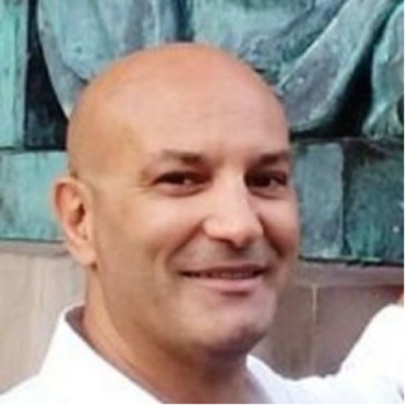 | Roberto Carella - MT Europe  Roberto Carella currently provides specialised support at Health Department of Apulia Region focusing on "One Health" as a catalyst for sustainable development according to SDGs. His focus is on critical issues such as health, environment, circular economy, digitalizartion and innovation.  He is also a project manager at MT-Europe where he emphasizes the transition journey especially in the fields of smart cities, smart territories, smart islands, focusing on sustainability and digitalization.  He holds his degree in Economics at University of Bari and an eBusiness PhD at eBMS ISUFI University of Salento, with a focus on Knowledge Management. Furthermore he is a public policy expert and university lecturer in management and sustainability. His consultative role in various institutional bodies has garnered him a reputation for efficacious stakeholder engagement and strategic vision in facilitating transition to a digital and greener economy.  LinkedIn  Organisation website: https://www.mt-europe.eu/
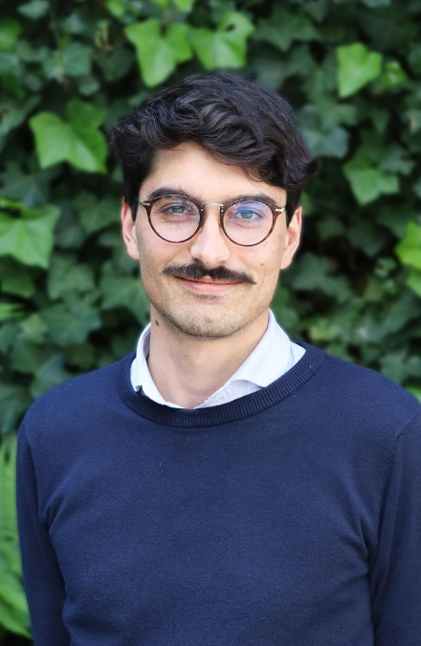 | Rodolphe Doité - FARI – AI for common good Institute Brussels  Rodolphe Doité holds a master’s degree in law, economics and management from the École Normale Supérieure de Rennes, as well as a Master’s in international and European Union law from the University of Paris 10 Nanterre La Défense. He is working as an Innovation Policy Expert at FARI, a non-profit university institute on AI, data and robotics focused on the Common Good, jointly initiated by two Brussels universities (VUB & ULB) – uniting interdisciplinary expertise across 10 research groups on AI, data, robotics, social sciences, ethics, and law. Before joining FARI, Rodolphe has been a Project and Policy Manager at ERRIN, collaborating with local and regional authorities to support research and innovation, as well as digital policies. With his involvement in the Living-in.EU movement, he has been working on LORDIMAS since its creation.  LinkedIn  Organisation website: Home - Fari Institute
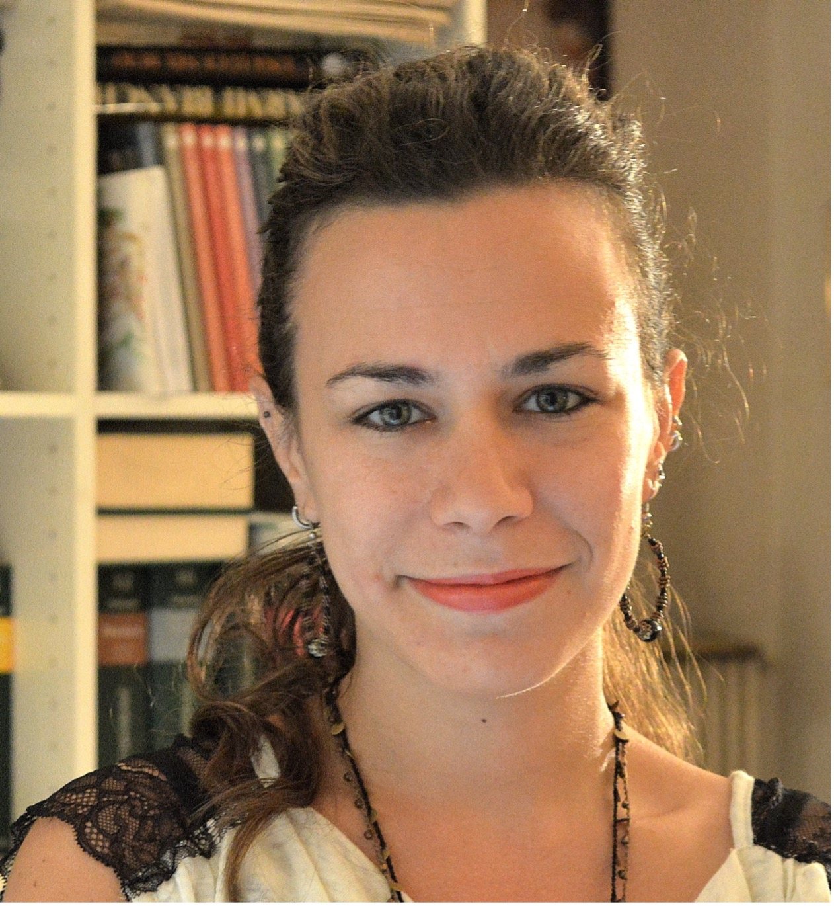 | Susanna Fontana - Fondazione FORMIT  Susanna Fontana is a Researcher, Proposal and Project Manager at FORMIT, specialising in digital transformation, security, and territorial development. She coordinates the Horizon Europe project RESONANT, developing tools and policy recommendations to tackle information suppression and foreign information manipulation (FIMI). Susanna is involved in NATO Science and Technology Organization’s Technical Teams: Human Digital Twin, Analytical Bias in Weak Signal Assessment, and Cross-Alliance Societal Attitudes to Emerging Technologies. With expertise in foresight for policy making, she supports strategic decision-making by analysing trends and weak signals. Recent publications include works on AI adoption, digital rights, smart specialisation, youth work policies, and digital cohesion.  LinkedIn  Orgnisation website: www.formit.org
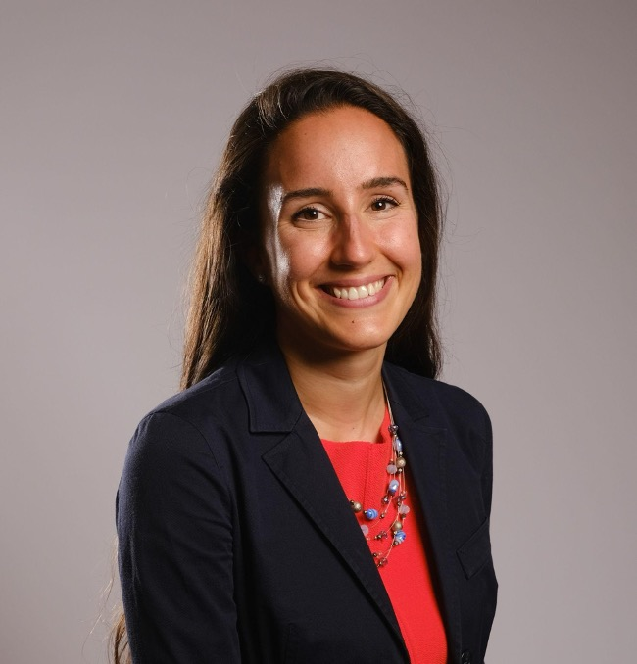 | Sveva Ianese - Data Valley Consulting / University of Padova  Sveva Ianese is a lawyer and academic researcher specializing in smart city ecosystems. Her work supports decision-makers in shaping future-proof urban environments through public-private collaborations.  She provides expert guidance on the regulatory impact of emerging technologies, translating complex legal frameworks into actionable policies. By bridging research, policy, and practice, she empowers urban stakeholders to drive innovation and sustainable growth.  In addition to her research, she serves on the Municipality of Turin’s Board for the Ethical Use of New Technologies. She also led a strategic initiative aimed at exploring the regulatory and technical foundations of urban data re-use. This working table involved academics, public and private players and provided a set of guidelines, while showcasing some best-performing projects across Europe.  LinkedIn  Organisation website: https://www.datavalleyconsulting.com/en
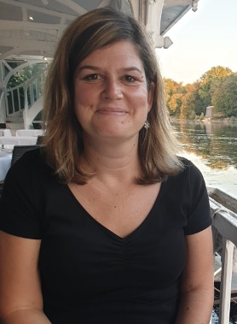 | Vanda Turczi - Burgundy-Franche-Comté Region  Vanda Turczi works for the Burgundy-Franche-Comté Regional Council as a project manager. She manages and facilitates the "Smart and Sustainable Territories" support program, which aims to foster the emergence of innovative, cross-sectoral projects for public actors in the region. She is also developing a methodology to assess the impact of services within smart territory projects.  Throughout her career, she has led several European digital projects. She is currently coordinating the Interreg Europe ENAIBLER project, which focuses on strengthening the capacity of public administrations to adopt Artificial Intelligence.  She holds a PhD in cartography, completed under joint supervision between the University of Orléans and Eötvös Loránd University, on Harmonization of thematic maps within the European Union – Design of an environmental template map according to European needs.  LinkedIn  Organisation website: https://www.bourgognefranchecomte.fr/

